
Arden University (Berlin)

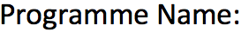
Maths for Data Science

COM7023

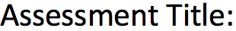
Maths for Data Science Portfolio

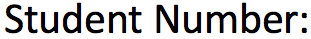
24169956

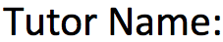
Prof. Ali Vaisifard

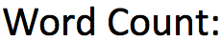
2944

Table of Contents

- Introduction 3
- Linear Algebra – Heat Flow Across the Steel Plate 4
  - Problem Description 4
  - Mathematical Model and Gaussian Elimination 4
  - Python Implementation and Numerical Solution 5
  - Interpretation of the Temperatures 6
- Calculus – Rate of Change of Temperature 7
  - Temperature Function Along the Edge 7
  - Derivative and Points of Fastest Change 7
  - Graphical Analysis Using Python 8
  - Practical Implications 9
- Probability – Size of Measurement Error 10
  - Modelling the Error as a Normal Distribution 10
  - Standardization and Probability Calculation 10
  - Interpretation for the Measurement System 11
- Hypothesis Testing – Mean Temperature at a Point 12
  - Sample Data and Goal of the Test 12
  - Hypothesis and Choice of Test 12
  - Manual Calculation of the t-Statistic 13
  - Python Confirmation of the Test 13
  - Decision and Practical Conclusion 14
- Discussion 15
- Conclusion 16
- References 17
- Appendix 18

Introduction

In this research, I look at a tiny mathematical model of heat flow on a steel plate that is utilized by the EU Steel Preparation Agency. The company hopes to use laser or plasma cutters to cut steel plates more effectively. They must comprehend how temperature affects the plate’s surface to accomplish this. The cutting quality may be unsatisfactory, and the operation becomes less effective if the temperature is occasionally too high or too low.
There are four primary mathematical components to the problem. First, I solve a system of four equations using linear algebra. The approximate temperatures at four grid points on the plate are described by these equations. Second, I investigate how the temperature varies along a single plate edge using calculus. Since this can indicate where the material may be under higher thermal stress, I concentrate on the areas where the temperature varies most quickly. Third, I compute the likelihood that a temperature measurement error is greater than a given value using probability. At the end, I have done hypothesis testing to determine whether the mean temperature at a particular area reaches the target value of 100 °C.
For every section, I’ve used both mathematical reasoning and Python code. While math explains the basic ideas and concepts, Python enables me to solve the issues and rapidly visualize the outcomes using Matplotlib. This combination is common in data science, where both theory and computation are often needed. I go into how the findings fit together and what they might signify for the business at the conclusion of the report.

Linear Algebra – Heat Flow Across the Steel Plate

2.1 Problem Description
We are given a steel plate with four grid points on which the steady state temperatures are to be determined. Let $x_{1} , x_{2} , x_{3 }and x_{4}$ be these unknown temperatures. A set of four linear equations is used to simulate the heat flow. Every equation connects a single spot to both fixed boundary temperatures on the plate and its neighbours.
The system is:
$$4x_{1}- x_{2} - x_{3 }=100$$
$${-x}_{1}+ {4x}_{2} - x_{4} =100$$
$${-x}_{1}+ {4x}_{3} - x_{4} = 0$$
$${-x}_{1}- x_{3} + 4x_{4} = 0$$
Boundary circumstances, such as the plate’s boundaries being held at such temperatures, are the source of the constant numbers 100 or 0 on the right. Coefficients like 4 and -1 show how each point is affected by heat from nearby points. The goal is to solve this system and find the numerical values of $x_{1} , x_{2} , x_{3 }and x_{4}$ , which estimates the temperature at each grid point in degrees Celsius.
2.2 Mathematical Model and Gaussian Elimination
To solve the system efficiently, I express it in matrix form as $Ax= b$, where
$A =\left[\begin{matrix}4 & -1 & -1 & 0 \\ -1 & 4 & 0 & -1 \\ -1 & 0 & 4 & -1 \\ 0 & -1 & -1 & 4\end{matrix}\right]$ , $x = \left[\begin{matrix}x_{1} \\ x_{2} \\ x_{3} \\ x_{4}\end{matrix}\right]$ , $b = \left[\begin{matrix}100 \\ 100 \\ 0 \\ 0\end{matrix}\right]$
This gives the enhanced matrix:
$$\left[\begin{matrix}A & | & b\end{matrix}\right] =\left[\begin{matrix}4 & -1 & -1 & 0 & | & 100 \\ -1 & 4 & 0 & -1 & | & 100 \\ -1 & 0 & 4 & -1 & | & 0 \\ 0 & -1 & -1 & 4 & | & 0\end{matrix}\right]$$
I transform this matrix into upper triangular form using Gaussian elimination. Eliminating the entries (the diagonal elements) beneath each pivot is the primary goal. For instance, the first pivot in the first row is 4. By adding appropriate multiples of the first row to rows 2 and 3, I may eliminate the -1 entries beneath it.
In Practice, this means performing row operations such as:​
- $R_{2}←R_{2}+\frac{1}{4}R_{1}$
- $R_{3}←R_{3}+\frac{1}{4}R_{1}$
The first column below the pivot equals 0 because of these actions. To produce zeros beneath it, I then proceed to the second pivot and repeat the procedure. The matrix is gradually converted into an upper triangular form with zero values for all entries below the main diagonal. Once in this form, I can solve for $x_{4}$ from the last row, then substitute upwards to find $x_{3}, x_{2}, and x_{1}$.
I get the following result if I perform all the computations (or verify using Python):

$$x_{1}=37.5, x_{2}=37.5,{ x}_{3}=12.5, x_{4}=12.5,$$

2.3 Python Implementation and Numerical Solution
I can also use Python to solve the matrix equation rather than doing all the algebra by hand. I use the built-in linear algebra functions in the NumPy package. The pertinent code is shown in Figure 2.3.1.
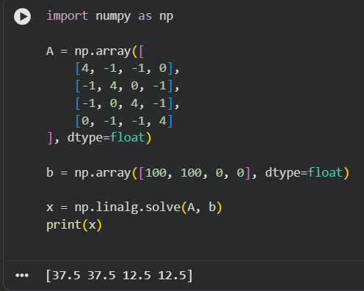
Figure 3.2.1: Python code and solution for the linear system.
This code creates matrix A and vector b and calls np.linalg.solve to find the vector x. The output is shown in Figure 3.2.1.

Point | Temperature (°C)
$$x_{1}$$ | 37.5
$$x_{2}$$ | 37.5
$$x_{3}$$ | 12.5
$$x_{4}$$ | 12.5

Table 2.3.1: Temperatures

2.4 Interpretation of the Temperatures
According to the numerical data, the lower grid points, 𝑥3 and 𝑥4, have temperatures of 12.5°C, whereas the top two grid points, 𝑥1 and 𝑥2, have temperatures of 37.5°C. According to this pattern, heat is concentrated closer to the areas of the plate that are associated with the 100°C border conditions. Because they are farther from the hotter edges and affected by the boundary at 0°C, the lower spots are colder.
This indicates that the steel plate does not reach a consistent temperature from a practical perspective. Certain areas are still much colder. Such temperature variations may have an impact on the quality of a laser or plasma cut. While cooler areas may demand more energy or result in uneven edges, hotter areas may be simpler to cut. Engineers can modify process parameters, like cutting speed or power, to get consistent outcomes throughout the entire plate by having a better understanding of these temperature distributions.

Calculus – Rate of Change of Temperature
3.1 Temperature Function Along the Edge
The temperature is modeled as a continuous function of position x along one edge of the plate:
$$T(x)=100sin\left(\frac{πx}{10}\right)$$
Where x is measured along the boundary between 0 and 10. This function describes the change in temperature from one end of the edge to the other. The sine curve shows that the temperature increases from zero to a maximum in the middle and then returns to zero at the opposite side.
In addition to calculating the temperature at each location, the goal of this section is to identify the spots where temperature fluctuates the fastest. In calculus, the rate of change is represented by the derivative 𝑇′(𝑥). After calculating the derivative, we may determine where the temperature gradient is larger; these places might be so important for material stress or cooling rates.
3.2 Derivative and Points of Fastest Change
I‘ve differentiated 𝑇(𝑥) with respect to 𝑥. To determine how quickly the temperature changes depending on the position. Using the chain rule:
$$T(x)=100sin\left(\frac{πx}{10}\right)$$
Gives
$$T^{'}\left(x\right) =100 ∙cos\left(\frac{πx}{10}\right)∙ \frac{π}{10}{=} 10π cos \left(\frac{πx}{10}\right)$$
The derivative shows the slope of the temperature curve at each spot. When $\left|T'(x)\right|$is big, the temperature changes rapidly; when $\left|T'(x)\right|$is small or zero, it changes slowly or not at all.
The maximum possible value of $\left|cos(θ)\right|$ is 1. So, the largest value of $\left|T'(x)\right|$ can be:
$$max\left|T'(x)\right| =10π∙1=10π ≈31.42$$
This occurs when
$$cos\left(\frac{πx}{10}\right) = ± 1$$
Solution:
- $cos\left(\frac{πx}{10}\right)=1 occurs$when $\left(\frac{πx}{10}\right)=2kπ ⇒x=20k$
- $cos\left(\frac{πx}{10}\right)=-1 occurs$when $\left(\frac{πx}{10}\right)=\left(2k+1\right)π ⇒x=10\left(2k+1\right).$
In the interval $0 ≤x ≤10,$ the relevant values are $x=0 and x=10.$ This indicates that the temperature fluctuates more quickly near the two ends of the edge.
3.3 Graphical Analysis Using Python
I plot the temperature function along the edge using Python to understand this behavior better. A straightforward Python script shown in Figure 3.3.1:
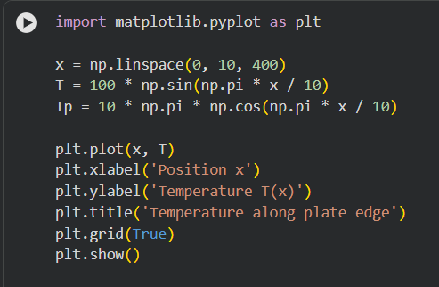
Figure 3.3.1: Python code for T(x)' along plate edge
The graph shown in Figure 3.3.2 displays a smooth sine wave that begins at 0°C at x=0, reaches a maximum of 100°C at x=5, and returns to 0°C at x=10. The derivative confirmed that the curve is sharpest close to the ends.
I can also plot the derivative T′ (x) if I'd like, but the main notion is that the steep portions of the curve correlate to high values of |T′ (x)|.
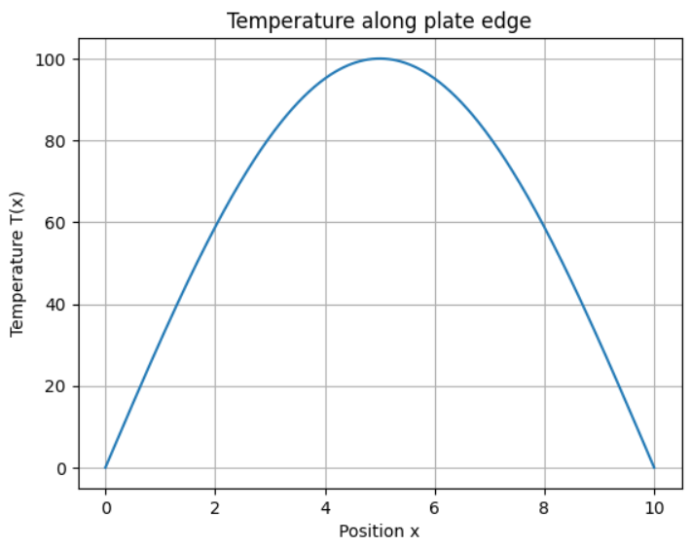
Figure 3.3.2: Graph of temperature along the plate edge.
3.4 Practical Implications
For the steel cutting process, it is helpful to know that the temperature varies most quickly around 𝑥 = 0 and 𝑥 = 10. Thermal stress in the material might result from abrupt temperature fluctuations. When the steel is cut or cooled, these tensions could cause distortion, cracks, or other flaws.
To lower the danger of damage, engineers may need to modify the cutting speed, power, or cooling flow if the cutting path passes through areas with extremely high gradients. On the other hand, the thermal conditions are more stable in the center area around 𝑥 = 5, where the temperature is high but varies more slowly. For crucial cutting tasks, this area might be more advantageous.
This section of the assignment shows how calculus may be used to identify the most important data science sites and examine trends in a function. Altogether, plots and derivatives offer a clear visual of how the physical system acts along a continuous dimension.

Probability – Size of Measurement Error
4.1 Modelling the Error as a Normal Distribution
There are errors in the temperature readings. The discrepancy between the measured and actual temperatures is represented by the error term E. It is assumed that the mistake in this assignment has a normal distribution with a mean $\overline{x}$ of 0 and a standard deviation (s) of 2°C:
$$E \sim N(0, { 2}^{2})$$
This indicates that while the measurements are generally accurate, individual readings may differ somewhat from the actual value. The inaccuracy is usually relatively modest, but it can occasionally be rather big.
What is the likelihood that the inaccuracy will be larger than 3°C? This is frequently expressed as P (|E| > 3). The measurement system could not be dependable enough for accurate industrial applications if this probability is significant.
4.2 Standardization and Probability Calculation
I use the following to transform error E into a standard normal variable Z to get the probability:
$$Z= \frac{E-0}{2}$$
Regarding the 3°C barrier,
$$P(E>3)=P\left(Z> \frac{3}{2}\right)=P(Z>1.5)$$
The cumulative distribution function at 1.5 is roughly $Φ(1.5)≈0.9332,$According to ordinary normal tables or Python. Consequently,
$$P\left(E>3\right)=1-Φ\left(1.5\right)≈1-0.9332=0.0668$$
If I want to know how big the error is in both directions (too high or too low), I figure out:
$$P\left(E>3\right)=2P\left(E>3\right)≈2 ×0.0668=0.1336$$
Therefore, there is a 6.7% probability that the error is larger than 3°C in the positive direction and a 13.4% probability that the error is larger than 3°C in either direction.
4.3 Interpretation for the Measurement System
For a substantial mistake (greater than 3°C in size), the probability of about 13% is not very modest. This indicates that the inaccuracy may be greater than 3°C in about 1 in 7 or 8 measurements. The steel cutting process's quality standards will determine whether or not this is acceptable.
Such a high likelihood of significant errors could be an issue if extremely precise temperature control is required. The business may then choose to add additional calibration procedures, take several measurements and average them, or enhance the sensors. This section of the assignment demonstrates how measurement system dependability can be evaluated using probability and the normal distribution. As shown in Figure 4.3.1.

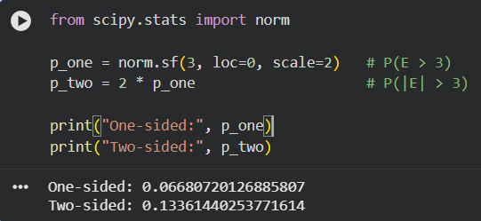
Figure 4.3.1: Python code: calculates the probabilities using scipy.stats.norm

Hypothesis Testing – Mean Temperature at a Point
5.1 Sample Data and Goal of the Test
The following eight temperature readings (in °C) are recorded by the company at a specific location on the steel plate:
$$99, 100, 98, 101, 97, 99, 100, 98$$
At this moment, 100°C is the target mean temperature. Whether these observed values support the goal mean or provide evidence that the true mean deviates from 100°C is the matter at hand.
I use a one-sample hypothesis test on the mean to address this. I employ a t-test instead of a z-test because the sample size is tiny and the population standard deviation s is unknown. As shown in Table 5.1.1.
Measure | Value
Sample size $n$ | 8
Sample mean $\overline{x}$ | 99
Sample standard deviation $s$ | 1.31 (approx.)

Table 5.1.1: Sample size, mean, and standard deviation for the recorded temperatures
5.2 Hypotheses and Choice of Test
Let $μ$ be the actual mean temperature at this moment. The hypotheses are:
- Null hypothesis: $H_{0}: μ=100$
- Alternative hypothesis: $H_{1}: μ≠100$
This is a two-sided test since I want to know if the mean deviates from 100°C in any direction, not just higher or lower.
I employ a one-sample t-test because the population standard deviation is unknown and $n=8$ is small. The test statistic is provided by:
$$t= \frac{\overline{x}- μ_{0}}{s/{\sqrt{n}}}$$
Where $\overline{x}$ is the sample mean, $μ_{0}=100$is the hypothesised mean, $s$ is the sample standard deviation, and $n$ is the sample size.

5.3 Manual Calculation of the t-Statistic
First, I’ve computed the sample mean:
$$\overline{x}= \frac{99+100+98+101+97+99+100+98}{8}= \frac{792}{8}=99$$
Next, I’ve calculated the sample standard deviation $s$ using the formula:
$$s= \sqrt{\frac{1}{n-1}\sum_{i=1}^{n}{{(x_{i}-\overline{x})}^{2}}}$$
If I figure this out (or use Python), I get $s ≈ 1.3093$.
Now, I compute the t-statistic using:
$$t= \frac{\overline{x}- 100}{δ/{\sqrt{n}}}= \frac{99- 100}{{1.3093}/{\sqrt{8}}}= \frac{-1}{{1.3093}/{\sqrt{2.8284}}} ≈ \frac{-1}{0.4630} ≈ -2.16$$
The degrees of freedom are:
$$df=n-1=7$$
I evaluate the p-value for 𝑡 = − 2.16 and 𝑑𝑓 = 7 to the significance level of $α=0.05$ to conclude. The two-sided p-value using software or a t-table is roughly 0.068.
Since $p ≈0.068>0.05,$At the 5% level, I do not reject the null hypothesis.

5.4 Python Confirmation of the Test
To confirm the manual calculations, I’ve used Python and the scripy.stats library as shown in Figure 5.4.1.
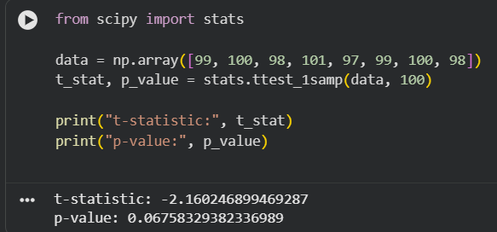
Figure 5.4.1: Python t-test output.
A one-sample t-test of the mean is carried out by this code. The result provides the two-sided p-value and the t-statistic. The t-statistic of around -2.16 and the p-value of roughly 0.068 are in line with the manual results.
5.5 Decision and Practical Conclusion
The p-value of roughly 0.068 is more than 0.05 at the 5% significance level. In other words, the outcome is not statistically significant. Thus, I am unable to reject the null hypothesis $H_{0}: μ=100$. In other words, there is insufficient data to draw the conclusion that the actual mean temperature differs from 100°C based on this sample of eight measurements.
In practical terms, the measured average of 99°C is close to the desired temperature of 100°C. The slight discrepancy can just be the result of a measurement mistake and chance variance. This implies that the current temperature is about on target for the company. To make sure that the process stays stable over time, it could still be prudent to gather additional data or to routinely check this point because the sample size is rather small.

Discussion

I compiled the findings from the four mathematical components in this section and considered their implications for the steel cutting procedure.
From the linear algebra portion, I’ve found that the four grid points on the plate have unique steady-state temperatures. Two of the spots are approximately 37.5 °C, while the other two are approximately 12.5 °C. This explains a clear temperature differential caused by the boundary conditions. This also implies that various areas of the plate will react differently to the identical cutting conditions.
Temperature changes along a single edge were examined in the math section. The function $T\left(x\right)=100sin\left(\frac{πx}{10}\right)$is middle of 100°C, and has ends of 0°C. The derivative showed us that the temperature varies most rapidly between x = 0 and x = 10. Because all of a sudden changes could result in thermal stress, and it can change the way the material expands or contracts, cutting near these places may need extra consideration.
The probability part has focused on measurement error with $E \sim N\left(0, { 2}^{2}\right),$The probability that the error is more than 3°C is around 13.4%. This isn’t that important. It tells us that individual readings may occasionally differ greatly from the actual temperature, even in many situations where the system is stable. For quality control, it may be better to use multiple measurements or smoother techniques rather than one value.
It was determined whether the average temperature at a certain position was 100 °C during the hypothesis testing. With a sample mean of 99 °C, a t-statistic of around -2.16, and a p-value of about 0.068, there isn’t enough evidence at the 5% significance level to decide the conclusion that the true mean varies from 100 °C. This suggests that the process is statistically close to the final objective.
Overall, these results tell us how linear algebra, probability, calculus, and hypothesis testing may be combined to achieve data-driven analysis of an industrial process.

Conclusion

This research has examined a simple mathematical model of heat transfer on a steel plate used in a cutting procedure. By solving four linear equations, I’ve found that the steady-state temperatures at the grid points, which have scores of 37.5°C and 12.5°C, aren’t uniform. This tells us the significant temperature gradients on the plate, which could be a reason to affect cutting efficiency.
I’ve used calculus to have a look at the temperature change along a plate edge. The derivative of the temperature function shows that the temperature changes more rapidly near the ends of the edge of the plate. Because those spots are more vulnerable to heat stress, these spots may require additional care while cutting.
The probability analysis of measurement inaccuracy shows that there is a noticeable chance of errors larger than 3 °C. This shows how important it is to understand sensor accuracy and consider strategies like repeated readings. The one-sample t-test on the mean temperature at one point has a result that the true mean is not significantly different from the goal of 100 °C at the significance level of 5%, which provides assurance that the process is proceeding as intended.
Overall, the assignment shows how Python and mathematical skills may be used to understand physical processes. In real-world data science and engineering problems, the same method can be used for larger datasets and more complicated systems.
At the end, the assignment shows how Python and mathematical abilities can be applied to understanding physical processes. The same approach can be applied to big datasets and much more complex systems in real-world data science and engineering challenges.

References

- Strang, G. and Herman, E. (2016) Calculus Volume 1. Houston, TX: OpenStax. Available at: https://openstax.org/books/calculus-volume-1/pages/1-introduction (Accessed: 17 November 2025).
- Illowsky, B. and Dean, S. (2023) Introductory Statistics 2e. Huston, TX: OpenStax. Available at: https://openstax.org/books/introductory-statistics-2e/pages/1-introduction (Accessed: 17 November 2025).
- NumPy Developers (2025) NumPy Documentation. Available at: https://numpy.org/doc/ (Accessed: 17 November 2025).
- Virtanen, P. et al. (2020) ‘SciPy 1.0: Fundamental algorithms for scientific computing in Python’, Nature Methods, 17(3), pp. 261-272. Available at: https://www.nature.com/articles/s41592-019-0686-2 (Accessed: 17 November 2025).
- Matplotlib Developers (2025) Matplotlib: Visualization with Python. Available at: https://matplotlib.org/ (Accessed: 17 November 2025).

Appendix

Import numpy as np
Import matplotlib pyplot as plt
From scipyimport stats
From scipy.stats import norm

A = np.array
([[4, -1, -1, 0],
[-1, 4, 0, -1],
[-1, 0, 4, -1],
[0, -1, -1, 4]
], dtype=float)
b = np.array([100, 100, 0, 0], dtype=float)
x = np.linalg.solve(A, b)
print(x)

x = np.linspace(0, 10, 400)
T = 100 * np.sin(np.pi * x / 10)
Tp = 10 * np.pi * np.cos(np.pi * x / 10)

plt.plot(x, T)
plt.xlabel('Position x')
plt.ylabel('Temperature T(x)')
plt.title('Temperature along plate edge')
plt.grid(True)
plt.show()

p_one = norm.sf(3, loc=0, scale=2)
p_two = 2 * p_one

print("One-sided:", p_one)
print("Two-sided:", p_two)

data = np.array([99, 100, 98, 101, 97, 99, 100, 98])
t_stat, p_value = stats.ttest_1samp(data, 100)

print("t-statistic:", t_stat)
print("p-value:", p_value)

GitHub Link: https://github.com/mirzasameer2000/Maths-for-Data-Science-Portfolio

